Creating a Consolidated/Container

Database Manually

STEP 1: Create the database directory
- Create all the necessary directories (folders) for the database
- Create folders for the following files
- pfile (pfile),
- archive log files (recovery_area)
- control files (oradata)
- datafiles (oradata) –multiplex as needed
- redo log files (oradata) – multiplex as needed
- audit files (adump)
- pdbseed files (pdbseed)
Set path for diagnostic_dest parameter in file
folder for scripts
STEP 2: copy a pfile and create database script from an already built container database
Pfile should include
*.db_block_size=8192
*.open_cursors=300
*.db_name='cdb1'
*.control_files='C:\app\Administrator\oradata\cdb1\control01.ctl','C:\app\Administrator\recovery_area\cdb1\control02.ctl'
*.compatible='12.2.0'
*.diagnostic_dest='C:\app\Administrator'
*.enable_pluggable_database=true
*.nls_language='AMERICAN'
*.nls_territory='AMERICA'
*.local_listener='LISTENER_cdb1'
*.processes=320
*.sga_target=2000m
*.audit_file_dest='C:\app\Administrator\admin\cdb1\adump'
*.audit_trail='db'
*.remote_login_passwordfile='EXCLUSIVE'
*.dispatchers='(PROTOCOL=TCP) (SERVICE=cdb1XDB)'
*.pga_aggregate_target=500m
*.db_recovery_file_dest='C:\app\Administrator\recovery_area'
*.db_recovery_file_dest_size=14250m

STEP 3: Create password file (UNNECESSARY if operating system authentication is available) and create a new instance
Enter the following command in OS command prompt to create a New Instance
- Password argument is the password for SYS user
- Maximum number of entries (users accounts) to permit in file
- Oracle service user password was “Passw0rd”
STEP 4: Set ORACLE_SID in command prompt to instance SID
STEP 5: Connect to the database instance
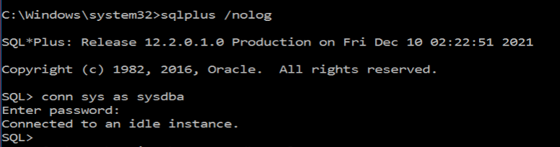
- For OS system authentication no password is required so you can press the enter key
- For Password file authentication enter the SYS password declared in STEP 3

Alternative method for OS system authentication
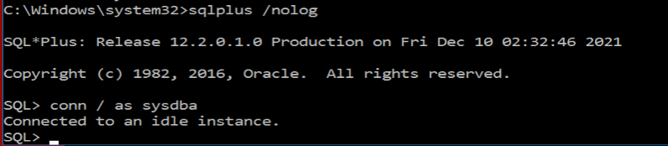

STEP 6: Create spfile from pfile (NOTE: make sure all file paths mentioned in the pfile exist and are correct)
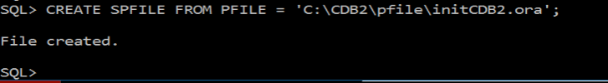
Perform this command every time the pfile is modified

STEP 7: Start database in nomount mode
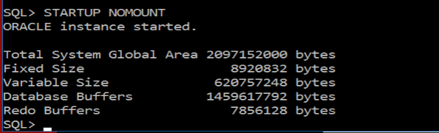

STEP 8: Run Database Create Script (NOTE: make sure all file paths mentioned in the create database script exist and are correct)
STEP 9: Run the following scripts in the container database CDB$ROOT
@?\rdbms\admin\catalog.sql
@?\rdbms\admin\catproc.sql
@?\rdbms\admin\utlrp.sql

Connect to CDB as SYSTEM user to run the following script in the CDB (check con_name)
@?/sqlplus/admin/pupbld.sql
- ‘?’ is a shortcut for oracle_home in SQL*PLUS

STEP 10: Open the pdb seed, PDB$SEED, in read and write mode
Set parameter _oracle_script to so you can put PDB$SEED in read and write mode
NOTE: PDB$SEED must be closed and reopened in read and write mode
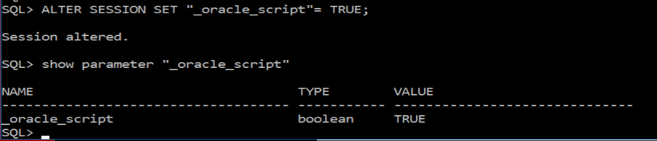
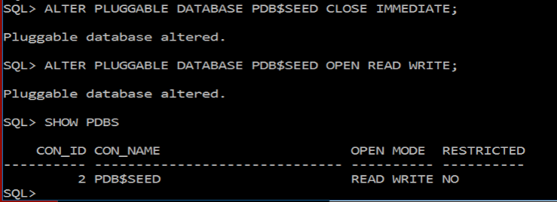
Alternatively, you can use the keyword FORCE to switch modes while the pdb is still open
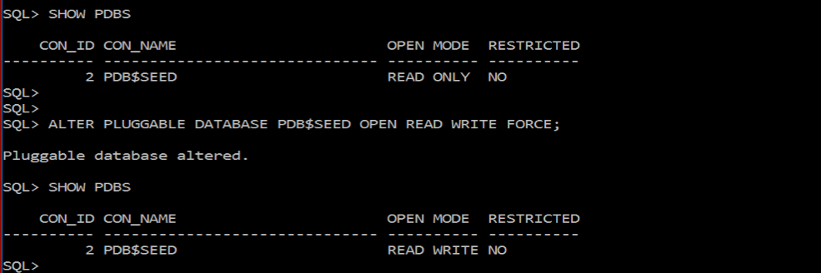

STEP 11: Set container to PDB$SEED and run the scripts below
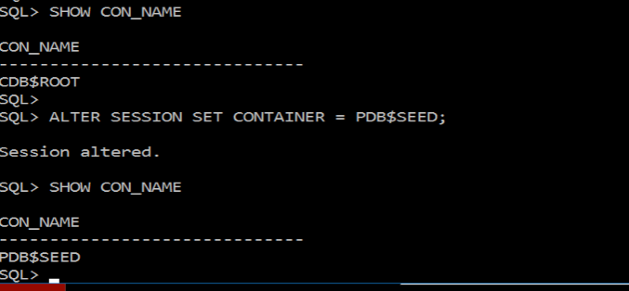

Run the following scripts
@?\rdbms\admin\catalog.sql
@?\rdbms\admin\catproc.sql
@?\rdbms\admin\utlrp.sql

Connect to CDB as SYSTEM user then set container to PDB$SEED and run the following script

@?/sqlplus/admin/pupbld.sql
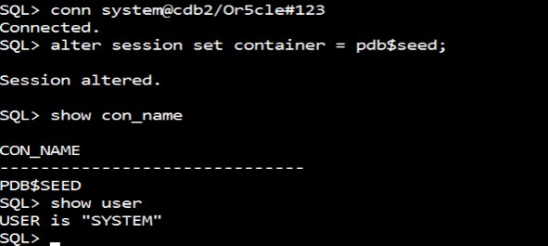
STEP 12: Verify components installed in the database on the root and pdbseed
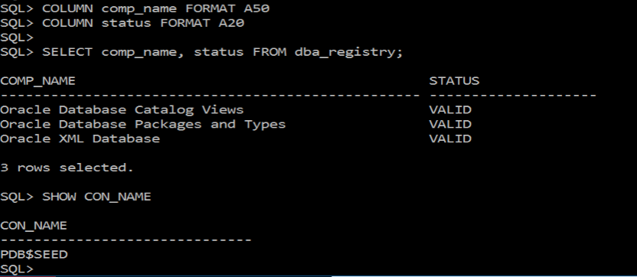
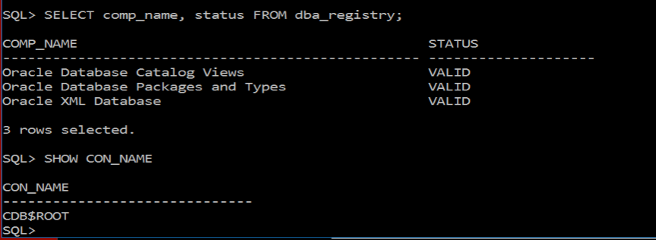

STEP 13: Shutdown database (make sure con_name is CDB$ROOT ) and enable Oracle Service Automatic startup
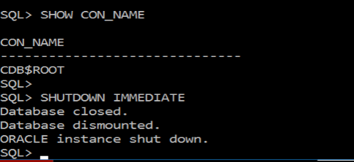

STEP 14: Modify tsn.ora file in oracle_home admin to include new database listener to the database SID to enable logging into database using SQL*Plus
filepath = C:\app\Oracle\product\12.2.0\Oracle_Home1\network\admin to include new database listener to enable connections to the database from the client end (e.g. using SQL*Plus)
“LISTENER_CDB2” is a default service name initialized in the pfile to allow connection to the database service, CDB2, which allows connections to the database. “CDB2” is a manually created service name that can also allow connections to the database service and database. “CDB2” would be listed in the listener services list WHEN it is active, but LISTENER_CDB2 does not appear on the listener service list whether it is active or not
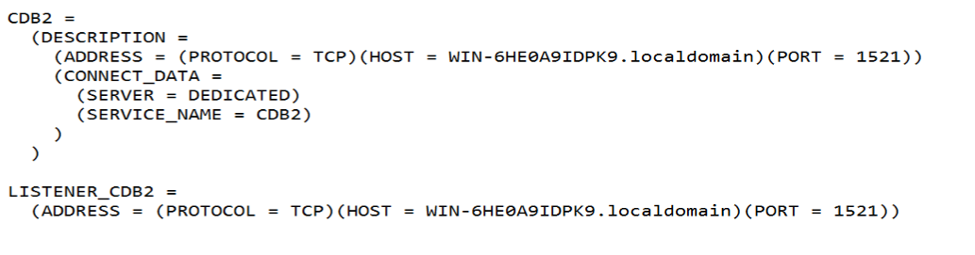

Creating a Pluggable database from a Seed PDB (PDB$SEED)

STEP 1: Connect to Database as SYS with SYSDBA Privileges

STEP 2: Check that you are connected to the root container CDB$ROOT and that PDB$SEED is opened in read only mode
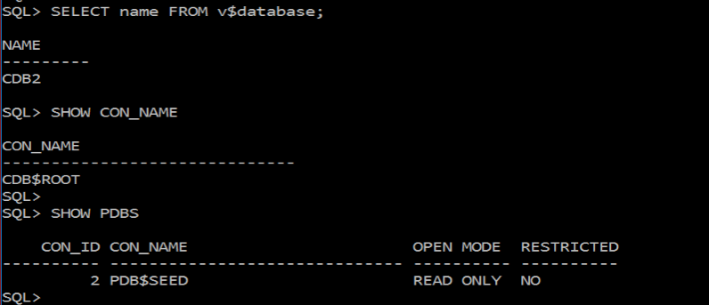

STEP 3: Make sure the appropriate directories (folders) exist. Then enter the CREATE PLUGGABLE DATABASE command for creating a pluggable database from a seed PDB. The admin user for the pluggable database is PDB_ADM. The newly created PDB1 is currently closed
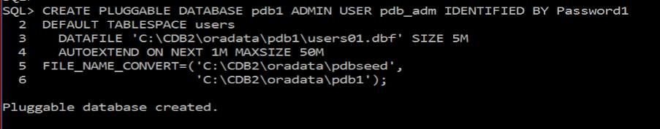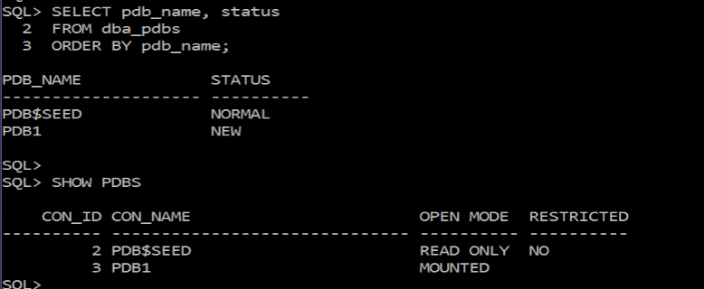
STEP 4: Open the PDB in read/write mode (use keyword FORCE if already opened)
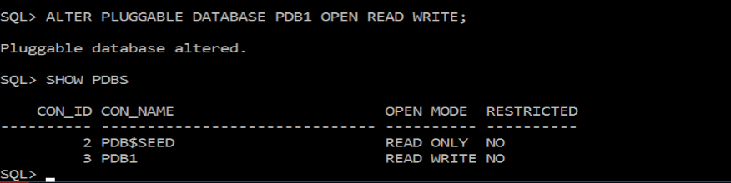

STEP 5: Verify the State of the PDBS
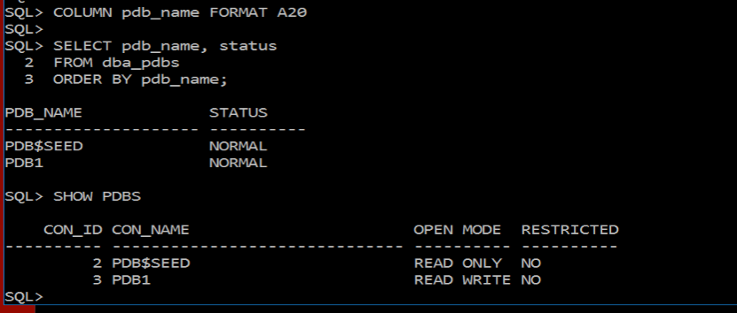

STEP 6 (OPTIONAL): If you want the PDB to automatically open on startup, you will need to save the state of the PDB after it has been opened in read/write mode
ALTER PLUGGABLE DATABASE pdb1 SAVE STATE;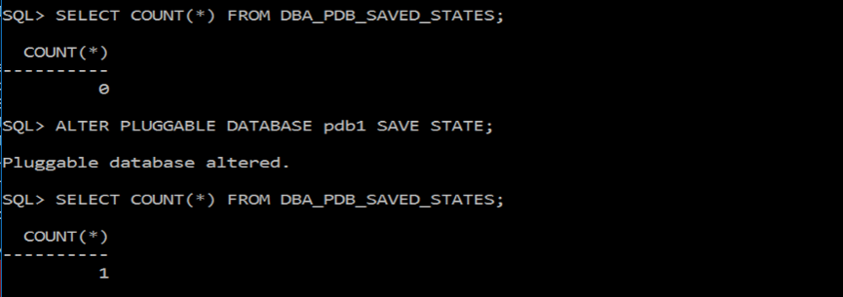alter

STEP 7: Modify tnsnames.ora file to allow connections to pdb
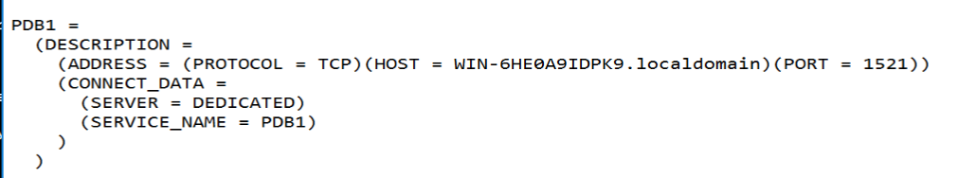

Cloning a Local PDB -- from the same Consolidated Database/(CDB)

STEP 1: Place the source pdb in read only mode
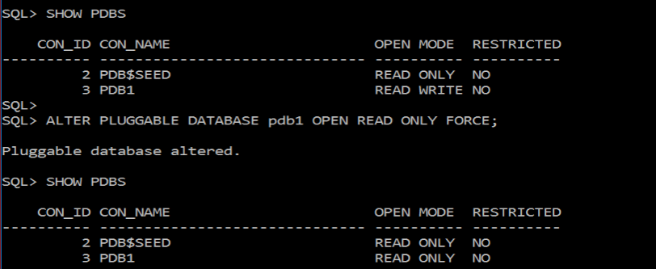

STEP 2: Make sure the necessary directories exist then Issue the Create PDB command
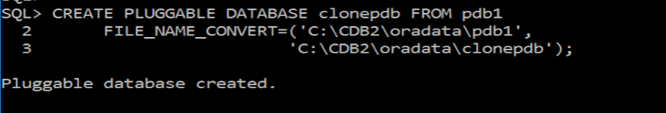

STEP 3: Check status of PDBS
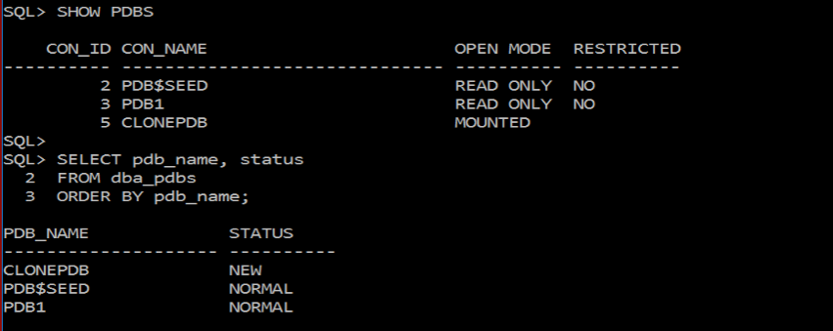
STEP 4: Open the pluggable database in read/write mode and set the source pdb back to read/write mode
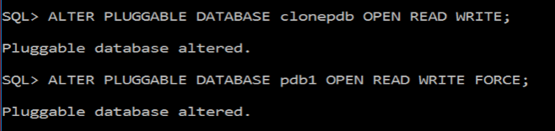

STEP 5: Show status of PDBS
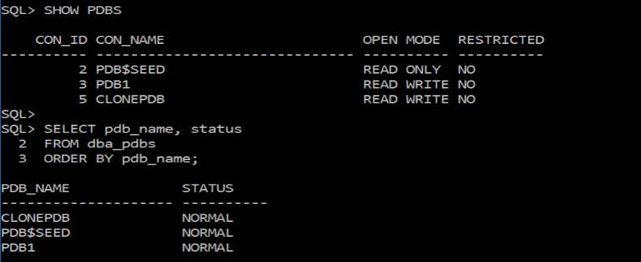

STEP 6: Modify tnsnames.ora file to allow connections to PDB

